

Submitted By:
Noor-Ul-Ain – 2025-CE-83
Assignment:
Lab No. 11
Submitted To:
Professor Mehmood

For the fulfillment of,
Circuit Analysis Lab
Department of Computer Engineering
University of Engineering and Technology, Lahore

LAB 11
PART 1
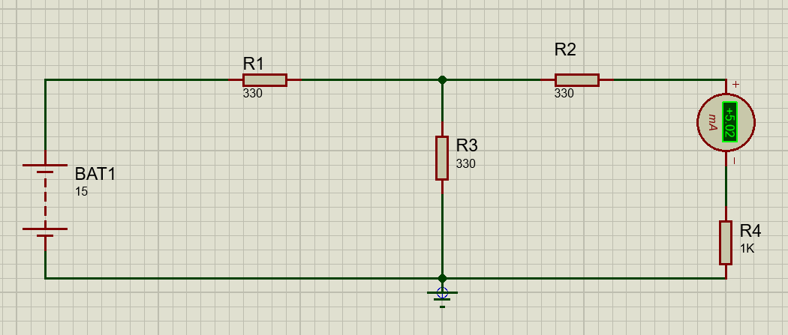
PART 2 CIRCUIT 1 (I mA)
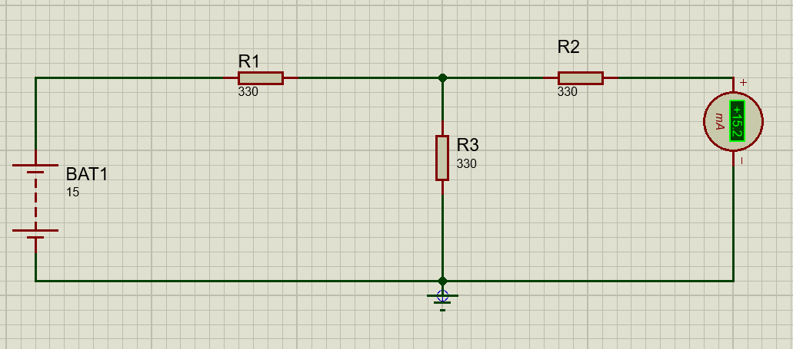

Part 3 RN

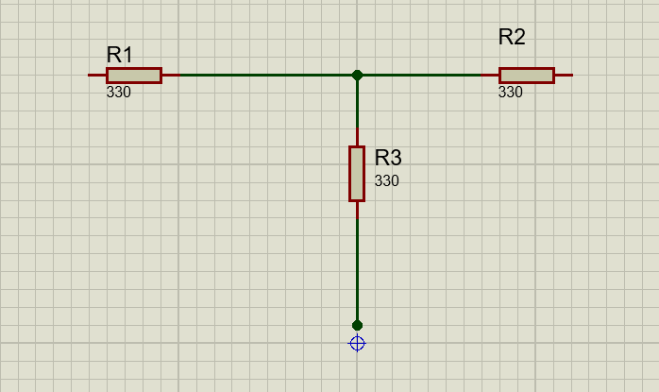

 | E (V) | IN(mA) | RN | IL(mA)
Practical values | 15 | 5.02 | 495 | 15.2

